National Heritage Academies
School Improvement Process Workbook

Student Intervention Services
June 2022

1.0 Overview - SIP Workbook

The school has created this schoolwide plan in order to outline and direct its schoolwide improvement efforts for the 2020 - 2021 school year and beyond. By evaluating and updating this plan, the school will meet state and federal requirements pertaining to schoolwide planning each year.
As part of the school’s Comprehensive Needs Assessment, the school analyzes and disaggregates norm-referenced and criterion-referenced, as well as authentic assessment data, to ensure that all students master academic goals and State standards. The results of the data analysis drive changes (if needed) to the school’s implementation of curriculum, instructional practices, professional development, and the school’s schoolwide plan.

1.1 Schoolwide Plan Introduction
Fill in the table with the planed date for each activity.
School Improvement Process Activities | 2022-23 | 2023-24 | 2024-25 | 2025-26
Comprehensive Needs Assessment & Goal Identification completed | 4/30/2022 | 4/30/2023 | TBD | TBD
Schoolwide Plan reviewed and updated | 9/30/2022 | 9/30/2023 | TBD | TBD
Effectiveness of school improvement process in school evaluated | 6/30/22 | 6/30/2023 | TBD | TBD
Modifications made to plan based on comprehensive needs assessment and evaluation of effectiveness of SIP efforts | 1/30/22 | 1/30/2023 | TBD | TBD
Title I Parent Meetings | 10/30/202 | 10/30/23 | TBD | TBD

2.0 Evidence of Collaboration - NY

Please complete the following chart with your SIP team members (add rows as necessary):
Stakeholder Collaboration
Schoolwide plan information is provided to the school’s Board of Directors via Board Meetings and/or additional documented correspondence. Students do not participate on the planning team as the school serves students in grades K-8.
These stakeholders work throughout the year and as the school conducts its formal school improvement activities in order to do the following: - Evaluate the mission statement, parent/family engagement policy*, parent-student compact*, and plan effectiveness - Analyze academic goals, criteria for success, strategies, and action activities in relation to data - Ensure alignment of the curriculum implementation and educational program to State standards in core content areas - Ensure specific objectives are evident in each core content area - Ensure instruction is delivered with appropriate teaching strategies that are based on research and best practice - Monitor the plan as evidenced by regular meetings - Build a comprehensive professional learning plan consistent with student academic performance needs - Identify parent and community resources that enhance instructor and student learning
*Note: Parents also contribute directly to the approval and/or revision of the parent/family engagement policy and the parent-student compact at the Title I Parent Meeting that is held in the spring each school year.

3.0 Collaboration with Teachers and Other School Staff (including Title I staff)

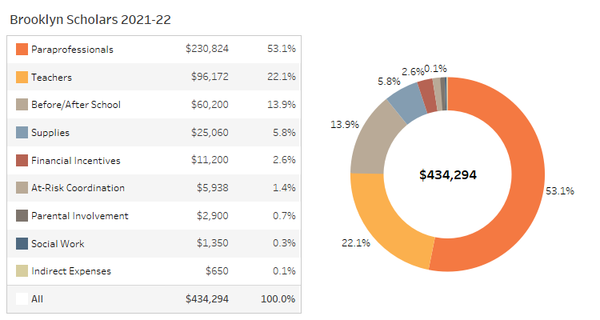
Figure: Grant Allocation Summary

Select a date for your SIP staff meeting.
04/04/2022

4.0 Collaboration with Parents

Select a date for your SIP parent meeting.
04/11/2022

5.0 Collaboration with the School Board

Please enter the date of your Board Meeting at which the SIP will be presented.
05/17/2022

6.0 Comprehensive Needs Assessment - Overview

The school conducts a comprehensive needs assessment annually as part of its continuous improvement process. While data is gathered and evaluated informally throughout each year, the school’s formal needs assessment takes place each spring. The school carried out its school improvement activities in order to identify priority needs and assess overall school and student performance. During this comprehensive needs assessment process, the school assessed data aligned with Department of Education guidelines, which have been established in order to provide schools with a comprehensive improvement structure based on current research and best practices. Specifically, data is collected and assessed as it relates to student achievement, school programs and processes, student/teacher/parent perceptions, and demographics. The school’s review of data includes that which is listed below, among others: - Student achievement on norm-referenced assessments (NWEA PGA and MAP) - Student achievement on criterion-referenced assessments - Student demographics - Discipline, tardy, truancy, and attendance rates - Parent/student perception surveys - Staff surveys, including teacher quality information - Curriculum alignment - Program implementation - Student engagement
The school has also engaged in the following school improvement activities as part of its school improvement process: the identification of particular focus areas within the school’s English Language Arts (ELA) and Math curriculum for each grade level; the development of corresponding grade level action plans; and the implementation of the formative assessment planning process.
The gathering and analysis of such data enables teachers to directly address student learning needs and gauge the degree to which the school-wide, grade-level, and individual student learning goals are being met, as well as provides the means by which comprehensive school improvement efforts are identified. Essentially, this data analysis serves as the primary driver for the school’s decision-making process as it relates to improvement; all goals, objectives, action steps, schoolwide reform strategies, professional development activities, and parent/family/community engagement decisions documented in this schoolwide/school improvement plan are driven by this needs assessment.

7.0 Staff Data

Staff data is collected in order to provide information on trends in staff experience, attendance, HQ status and satisfaction year over year.
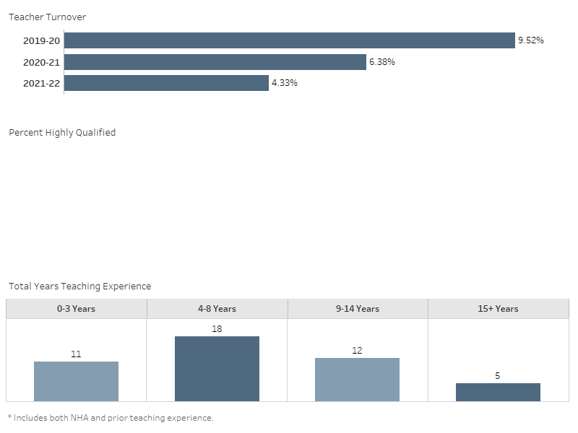
Figure: Teacher Turnover, % Highly Qualified, and Years Teaching Experience

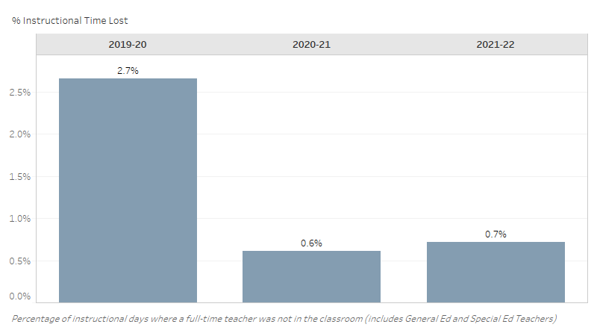
Figure: Teacher Absences and % Instructional Time Lost

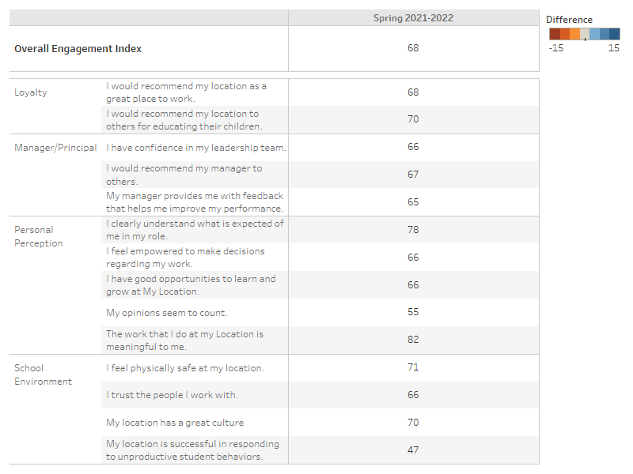
Figure: Staff Perceptions

What trends do you notice in your school staff data?
The data show some of the following trends: Teacher Turnover have been decreasing for the past three years. The percentage of our teachers who left last school year is 4.33%. At the same time the percentage of staff who are Highly Qualified have reached a 75% high which is also an upward trend from previous years. Another trend that is shown in the data is the amount of years of experience. The majority of our teachers have been teaching for more than 4 years. The data also show a big drop in the % of Instructional Time Lost which is at 1.1%. The only trend that shows a decline in our Overall Engagement Index for our staff, we went from a 76% to a 72%.
Are there action steps you are taking/will take to impact this trend? If yes, what are they?
The School Leadership Committee, comprising of staff and leadership, meets regularly to review different trends and checks-in with the school community to create action steps that can positively impact the specific trend. Unfortunately, the current climate and CDC protocols prevented many of the teambuilding opportunities both on and off campus. One of the trends that definitely needs to improve is our Overall Engagement Index. In order to improve overall engagement we survey staff more often (each quarter) in order to gauge the pulse of the staff. We could also be more intentional in planning ways to assure that concerns are voices and action will be taken to remedy the issues.

8.0 Parent Perception Data

Parent perception data is collected in order to provide information on trends in parent satisfaction year over year.
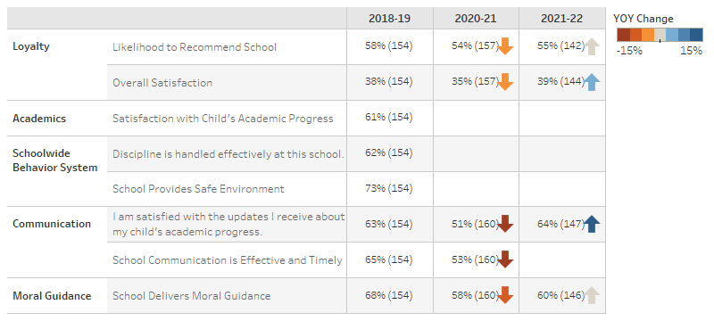
Figure: Parent Survey Results

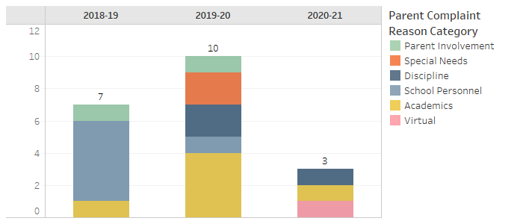
Figure: Parent Complaint Counts

What trends do you notice in your school parent perception data?
Parent complaints for academics was greater in 2019-2020 compared to the previous and current school year. This maybe a result of the pandemic which started in March 2020, where students had to do remote learning at home. This same school year had the highest parent complaint counts as well most likely due to the parents/guardians ability to navigate technology during remote learning. Parents are concerned about discipline and academics. There have been no complaints thus far regarding students with special needs or parent involvement, which is an improvement from other years. Behavior has been a consistent complaint for the past 3 years.
Are there action steps you are taking/will take to impact this trend? If yes, what are they?
The action steps that will impact this trend are: over communication, and communication by way of email, class dojo, post cards, newsletter, robo-calls, phone calls etc. meetings( both in person and virtual). The SEL Team will continue to bridge the gap between home and school by doing home visits and finding resources to assist parents and scholars. There needs to be a reset of the Parent Action Committe to find more opportunities to engage parents and get them more involved in the school community.

9.0 Demographic Data

Student Demographic Data is collected to demonstrate trends in enrollment, attendance, mobility and discipline year over year.
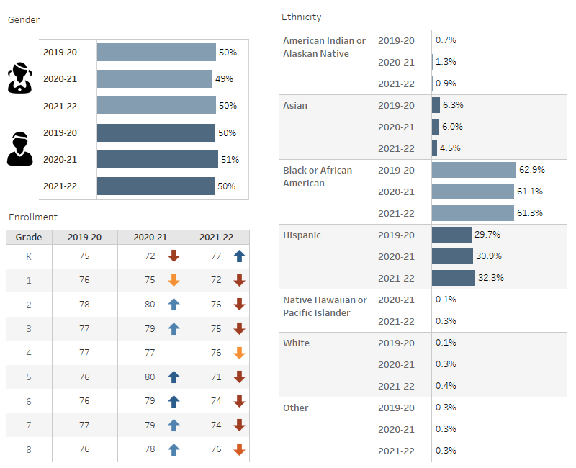
Figure: Gender, Ethnicity, and Enrollment

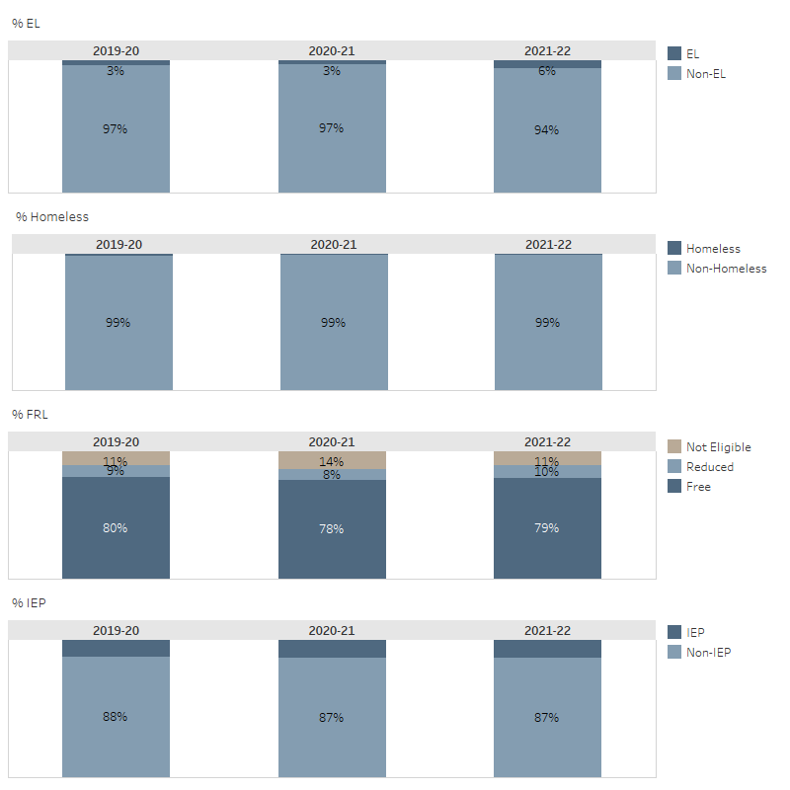
Figure: % EL, % Homeless, %FRL, % IEP

What trends do you notice in your school student demographic data?
The numbers in the Demographic Data have not changed significantly over the past few years. The numer of IEP students have increased slowly. The number of homeless student decreased from 2019-2020 to 2020-2021. The number of EL students have decreased steadily from 2018-2021 by 3%. Enrollment is also down in kindergarten and first grade as opposed to any other grade level.
Are there action steps you are taking/will take to impact this trend? If yes, what are they?
Two of the components of the Demographic Data that we have been trying to improve is the % of EL students and IEP students. Some of the steps that have been taken to improve these two numbers are modifications made in our enrollment priorities for the lottery. Our admission rep has been canvassing the neighborhood daycare providers to market our school to increase application in kindergarten. Teachers are also more in tune with noticing student deficiencies. The IAT committee and our social worker have been an integral part in providing documentation for students, teachers, and families in support of IEP and ELL services.

9.1 Student Attrition Data
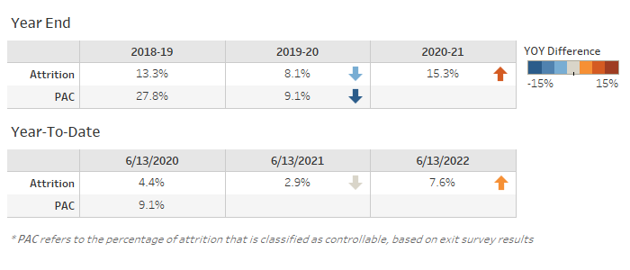
Figure: Student Attrition

What trends do you notice in your school student attrition data?
According to the data attrition is up in the 2020-2021 school year because attrition was impacted by the pandemic in that many families moved out of state or opted for schools that offered a remote option. The trends that are noted was a decrease frm 2018 to 2019 then an increase from 2019-2020. The isolation and economy were negative effects of the pandemic which caused jobs to become obsolete whereby causing families to relocate.
Are there action steps you are taking/will take to impact this trend? If yes, what are they?
We want to continue to improve the lines of communication with parents and build relationships with students to impact attrition data positively. Deans have been instructed to make contact with families each month to solidify relationships with the school. We will also engage new families once a month after the lottery to ensure enrollment goals are maintained.

9.2 Student Attendance
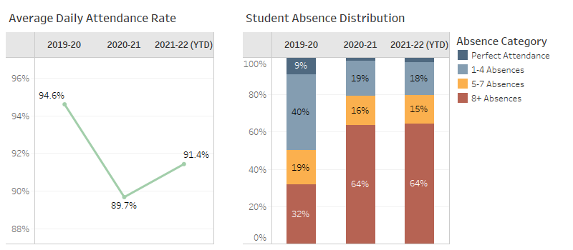
Figure: Student Attendance

What trends do you notice in your student attendance data?
The attendance rate for the 2021-2022 shows an increase of 1.8% from the previous school year. Additionally, there is a 14% decrease in scholars who have more than 8 absences. This data may be skewed due to remote learnng. The use of two-way commnication also helped with attendance.
Are there action steps you are taking/will take to impact this trend? If yes, what are they?
The attendance rate has increased due to the full return of in-school instruction. With the use of Class Dojo, Google Classroom, and Parent Connection sessions, teachers have built relationships with parents to make contact to check on scholars and encourage attendance efforts.

9.3 Student Discipline
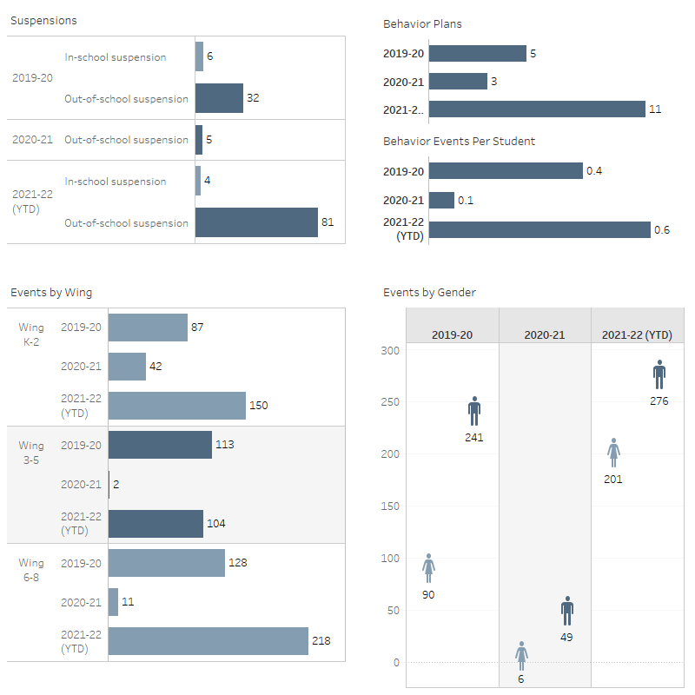
Figure: Suspensions, Events By Wing, Events Per Student, Events By Gender

What trends do you notice in your student discipline data?
Student discipline has increase in the 21-22 school year. At this point students had been home due to pandemic protocols. Students need to learn how to socialize effectively again. The increase in behavioral concerns are also due to the inconsistency with moral focus assemblies, students incentives, extended learning opportunities, and parent engagement.
Are there action steps you are taking/will take to impact this trend? If yes, what are they?
We can impact this trend by engaging students in social emotional learning, intentional moral focus assemblies, and ongoing parent communicatoin.

10.0 School Community Summary

Provide a summary of unique features and challenges associated with the community in which your school resides. Include demographic and economic information.
Since the late 1950's East New York has had some of the highest crime rates in Brooklyn, and is considered by some to be the borough's murder capital, alongside Brownsville. Many social problems associated with poverty from crime to drug addiction have been prevalent in the area for decades. Despite the decline of crime compared to their peaks during the crack and heroin epidemics, violent crime continues to be widespread in the community. East New York's 75th Police Precinct reported the highest murder rate in the city in 2011, according to crime reports compiled by DNAinfo.com. East New York has significantly higher dropout rates and incidences of violence in its schools. Students must pass through metal detectors and swipe ID cards to enter the buildings. Other problems in local schools include low test scores and high truancy rates. Over half the population lives below the poverty line and receives public assistance (Temporary Assistance for Needy Families [TANF], Home Relief, Supplemental Security Income, and Medicaid). During the 1960's, East New York transitioned from being predominately Jewish and Italian to being predominately African American and Puerto Rican. However, now East New York is more diversified, with large African American, Puerto Rican, Dominican, West Indian, and South Asian populations. Due to gentrification of other Brooklyn neighborhoods, closer to Downtown Brooklyn and Manhattan, such as Bushwick and Bed-Stuy, East New York now has one of the fastest growing Black, Latino, and Asian populations in the city. Brooklyn Scholars Charter School is located in southeast New York and is part of Kings County. As of 2010-2014, the total 11208 zip code population is 92,262, which has grown 5.85% since 2000. The population growth rate is higher than the state average rate of 3.26% and is much lower than the national average rate of 11.61%. 11208 zip code median household income is $34,527 in 2010-2014 and has grown by 27.51% since 2000. The income growth rate is lower than the state average rate of 35.25% and is about the same as the national average rate of 27.36%. 11208 zip code median house value is $423,100 in 2010-2014 and has grown by 166.60% since 2000. The house value growth rate is much higher than the state average rate of 90.79% and is much higher than the national average rate of 46.91%. As a reference, the national Consumer Price Index (CPI) inflation rate for the same period is 26.63%. On average, the public school district that covers 11208 zip code is much better than the state average in quality.

11.0 Student Interim Data
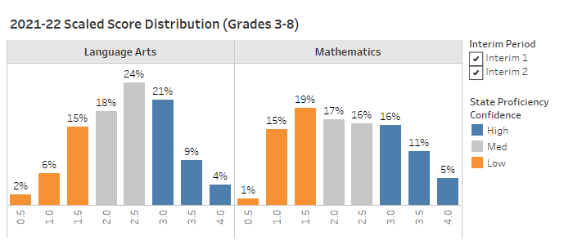
Figure: Interim Scaled Score Distribution

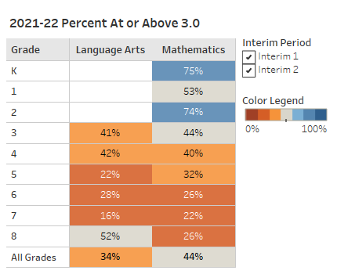
Figure: Interim Percent At or Above 3.0

What trends do you notice in your student interim data?
Interim data is consistent with learning loss after virtual and hybrid learning for the past 2 years. Our math program is manipulative based and the reading program requires strategic intervention and more staffing to provide the service to our scholars. The interim data shows that scholars scored overall higher in Math than ELA. In grades 3-8 grades, 3 and 4 showed proficiencies in the 40% range. Grades 5-8 showed lower proficiency percentages. The difference in average proficiency scores may be the result of learning loss over the past two years coupled with the rigor of the grade levels.
Are there action steps you are taking/will take to impact this trend? If yes, what are they?
In-person learning is making a stark difference in our interim data. We have planned more data days after each interim in K-8 as well as Intervention. During each Data Analysis Day, action plans will be created with targeted goals to be implemented. New curricular tools in Math and ELA must be aligned to common core standard-based skills. Implementing a structured intervention plan that targets and tracks students' performance as they work on grade level gaps would support academic growth.

12.0 State Test Data
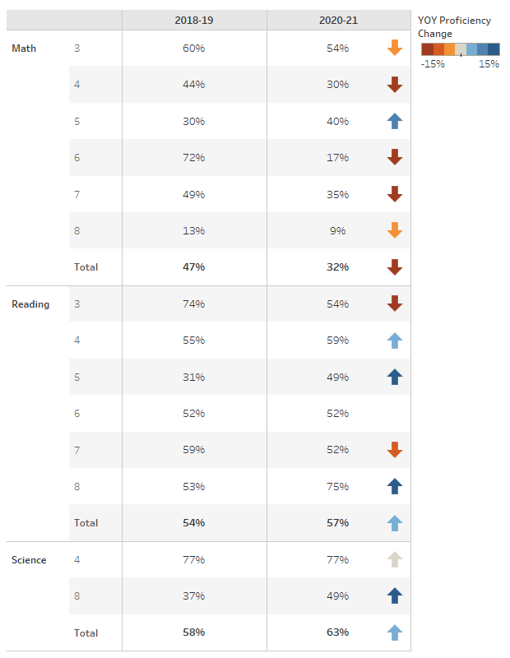
Figure: State % Proficient by Grade

12.1 Subgroup State Achievement Data

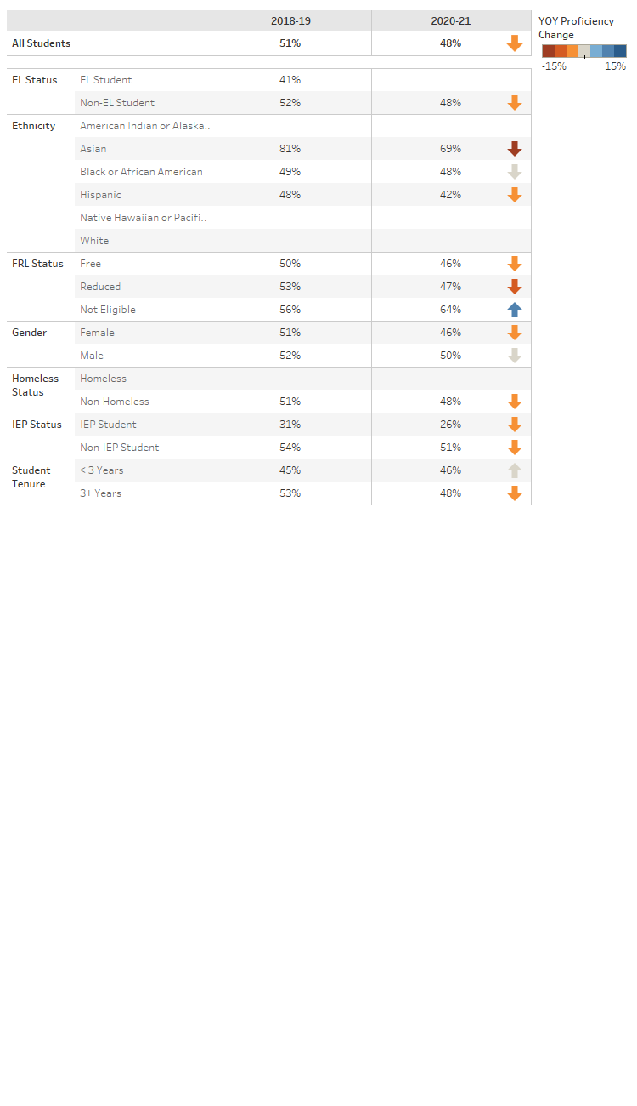
Figure: State % Proficient by Subgroup

What trends do you notice in your student state test data, by grade, by subgroup?
The trends show that each subgroup has had some improvement through the past years. There was, however, a slight decrease with the EL students in Reading and the Female students in Science.
Are there action steps you are taking/will take to impact this trend? If yes, what are they?
To continue the path of increasing scores within the subgroups, students will be supported with in class intervention along with push-in intervention, the Intervention Assistance Team, after school services, and the EL teacher (who infuses Imagine Learning Language and Literacy and Learning Ally programs specialized for EL students).

13.0 Comprehensive Needs Summary

Reading
What strengths and challenges in Reading have been identified?
-Students are 2-3 grade levels behind due to virtual instruction during the pandemic -Noticed that the questioning in the shared reading playbook is not coherent with the questioning in the assessment (Edcite) -scholars who need corrective reading daily are not receiving the program in grade 3-8 - Students don't have a love of reading. -The implementation of Lexia has been successful in K-2 but not so much in 3-8.
What trends have been identified in Reading?
Lack of comprehension, sight word recognition, Students struggling with fluency
Are there action steps you are taking/will take to impact this trend? If yes, what are they?
-Looking at the assessment questioning and incorporating that into the HOT questions -Including more culturally responsive text to empower students to make connections. -Providing incentives for the diffrent levels reached on Lexia
Writing
What strengths and challenges in Writing have been identified?
Challenges- Writing is the shortest block, but all students struggle with writing K-2 create their own writing curriculum according to monthly genres. No curriculum
What trends have been identified in Writing?
Students in lower grades have difficulty typing (virtual issue) Students struggle with syntax, grammar, and spelling Phonics must be implemented in the lower grades (K-2) so that these skills translate to the upper grades. Students in upper grades have difficulty formatting essays due to the lack of a specified writing block. conferencing with students have not been consistent. With the increased use of technology, many students are not focused and are plagiarizing work.
Are there action steps you are taking/will take to impact this trend? If yes, what are they?
We look at writing trends in their writing and reading responses to see which areas they need practice or help in grammar. That determines what grammar lesson we do for that week. Ther emust be a designated time to address grammar.
Math
What strengths and challenges in Math have been identified?
Strengths Resources for different learners (iReady, Khan Academy, Aimsweb) More participation/better attendance in grade 7th Abundance of data from different realms Students’ navigation skills in the virtual world Prior to COVID, intervention was revamped and students were being serviced each day in core areas; this lead to our upward trajectory Prior to COVID, math manipulatives and hands-on learning allowed students to make better connections to concepts Challenges -Students lacking prerequisites for current grade level -Lack of digital manipulatives -Lack of communication between NHAs head of math and BSCS -Keeping students on-task; more distractions at home -The idea that OpenUp Resources (Illustrative Math) begins content at grade level assuming students have mastered previous grade level skills. There is a pre-assessment students take prior to the start of a new unit but there are no RTI strategies or resources provided for students with deficiencies -Too many skills being taught at once. With the math story, number corner, lesson etc. -Bridges and Illustrative math are both manipulative based programs.
What trends have been identified in Math?
Students show difficulty bridging connections with skills and real life applications Vertical alignment proves that students are lacking a number of skills necessary to conceptualize new and more complex problems Teachers lack of HOTQs and providing students with opportunities to come face to face with the math itself Students lack basic math skills on each grade level.
Are there action steps you are taking/will take to impact this trend? If yes, what are they?
More small group instruction “workshop” Provide an opportunity to reteach and spiral Content meetings where teachers brainstorm HOTQs using question stems More PD surrounding curricular tools Intentional intervention for math based on interim data
Science
What strengths and challenges in Science have been identified?
Strengths - Access to great resources like- Stemscopes Having access to resources and supplies needed for practical activities. Expanding the STEAM program to include computer science (coding) Students have a genuine interest in science Challenges- Involving students in hands-on activities due to behavior and re-framing socialization because of covid. There has not been a consistent science teacher in the 8th grade.
What trends have been identified in Science?
Students perform better in multiple choice questions,improvements necessary in open ended questions and application questions.
Are there action steps you are taking/will take to impact this trend? If yes, what are they?
Use of more open ended and application questions for assessments and exit tickets including past state exam questions. More one and one, small group instruction.
Social Studies
What strengths and challenges in Social Studies have been identified?
The social studies curricula has a number of questions that are CC aligned and requires students to infer and make different connections A variety of media can be accessed to help students “see” history Strengths- Students generally have an interest in the topics discussed and it represents an opportunity to put skills learned in ELA into practice. Lessons often offer students the chance to think about their own lives and make personal connections to the topic discussed. Moral Focus is infused through the discussion of events and individuals who have displayed these characteristics throughout history. Challenges- Vertical integration of the curriculum is not evident. Scholars often arrive in 7th grade with limited knowledge of social studies skills such as geography and often report that they have not completed many social studies units that are listed on the NYS Social Studies Scope and Sequence (see https://www.weteachnyc.org/resources/resource/social-studies-scope-and-sequence-grades-k-8/ for scope and sequence). These challenges limit the ability to complete Social Studies lessons at higher levels as skills that should have already been acquired need to be addressed. Additionally, there is little guidance from NHA as to how to teach Social Studies. While we have "Playbooks" for ELA and Math, no such playbook exists for Social Studies in New York. This severely hinders the ability of a teacher who is not an expert on the content to be able to identify resources to use in the classroom, and it is easy to see why the topic would receive less focus than the other core classes. Another challenge is the comprehension aspect; there is a lot of reading involved. Understanding text structures such as sequence and cause and effect is a must to appreciate and understand history.
What trends have been identified in Social Studies?
Social studies is never treated as a “core” class despite the fact that it exposes students to informational text and RI standards Lack of current events being used Scholars tend to improve in Social Studies between 7th to 8th grade. This may be due to a need to develop their social studies skills from the ground up which can be very challenging. Scholars also often struggle to adjust to being asked to form their own opinions about a topic instead of finding a correct answer in a text. This implies that more focus should be placed on the development of critical thinking skills at all levels in conjunction with increased and intentional Social Studies lessons
Are there action steps you are taking/will take to impact this trend? If yes, what are they?
Teach text structures and use more text structure graphic organizers to organize the content Utilize current events resources like NEWSELA I would be happy to help identify ways to increase Social Studies education at all levels of Brooklyn Scholars. Teachers may be guided to the Scope and Sequence or other resources that may be used in the classroom. In a larger picture, I would be happy to help NHA develop a clearer Social Studies "playbook" in a similar way we have playbooks for ELA and Math
Student Interventions
How does your school make sure all students learn at a high level?
Differentiation Data digs for specific learning targets Higher order thinking questions Engaging students in productive struggle.
How does your school identify students who need intervention?
IAT team Teachers refer to students who they think need to be in tier 3 based on the data and performance in class. The process is about 6 weeks Teacher referral The school identifies students who need intervention by administering various assessments such as aimsweb, which monitors how students are progressing throughout the (school) years.
How does your school intervene for students who need the most instruction support (both in the classroom and through intervention programs)?
Providing 1 to 1 instruction when needed Small group settings Reading mastery/ corrective reading Balanced literacy instruction SETSS ICT Reaching out to the CSE for support
How does your school determine if the needs of those students are being met?
Progress monitoring (Aimsweb, Lexia, Dreambox) Data digs with standard proficiencies and deficiencies Intervention and the SPED team monitor the progress of these students weekly, or biweekly.
How are your teachers involved in analyzing student achievement data to improve the results of all students?
Teachers may spiral back on standards that are not met with a 2.0 or higher overall Teachers compare data from different quarters to determine where data rises or lowers Teachers make suggestions on what areas students need to revisit so that when broken down into smaller groups, those targeted areas are worked through.
Highly Qualified Staff
What does your school do to attract and/or retain high quality teachers (different from the things NHA might do on your behalf)?
We take staff referrals We network with other Principals to share candidates that may fit other schools We have had an open house where candidates came in for a day of touring and interviewing. Observations to make sure that staff maintains work ethic
Staff Professional Development
What staff development offerings were the most effective last year?
One of the most effective staff development offerings this past year was the technology tool PD (intro to Goalbook, Jamboard, Google Classroom, Pear Deck, Google Meet, Flipgrid, Class Dojo, Padlet, Flocabulary, CommonLit, and Read Works) (Alvarez agrees! Thanks to this PD, I was able to feel more comfortable with using google classroom and google meet.) Trauma PD from the SEL team
How do you know the PD was effective?
Tech tool PD- All staff at BSCS use the features of Google Classroom to connect with their students. Tech tool PD- All staff utilize digital resources to engage students Trauma PD- Staff are more conscious of the struggles our students are experiencing amidst this pandemic “Application is the evidence of learning,” - PT
How will the learning be sustained moving forward?
Refresher/crash courses Sharing best practices Continued education Resource courses Being data driven; this is the only way to know if learning is really sustained or not. This means teachers should go back to those “Below 2.0” standards and reteach, reassess. Even standards that were mastered need to be revisited and reassessed to compare data PD by specific content with the focus on vertical alignment.
What kinds of training or support would benefit your staff this upcoming school year and why?
Culturally Responsive/Sustaining Teaching to aid teachers in selecting culturally relevant texts for classes to read Unconscious Bias training to help teachers recognize and acknowledge implicit behaviors that could negatively impact student learning
Schoolwide Reform Strategies
The school educational program is grounded in the principles of Effective Schools Research, which was originally developed by Ronald R. Edmonds, who served on the faculties of Harvard University and Michigan State University. Effective Schools Research recommends research-based school attributes that are associated with quantifiably improved student learning. By definition, an “Effective School” is one in which all children obtain at least the essential knowledge, concepts, and skills needed to be successful at the next higher level. Within the Effective School, there are seven unique characteristics that correlate with school effectiveness. The school, a public-school academy, has adopted these characteristics as part of its promise to deliver a high-quality educational option for parents of the community. A summary of the Effective School correlates is as follows: - Clear School Mission - High Expectations for Success - Instructional Leadership - Frequent Monitoring of Student Progress - Opportunities to Learn and Student Time-on-Task - Safe and Orderly Environment - Strong Home-School Relations
In addition to adopting these characteristics of Effective Schools Research, the educational program includes a “Back to Basics” approach, a longer school day, and structured discipline, and the curriculum includes a moral focus component based on the Greek cardinal virtues. The educational program utilizes a curriculum that is scientifically research-based, aligned with State standards, and designed to ensure college opportunity for each child that the school serves.
While Effective Schools Research serves as the foundation of the school’s educational program, it has adopted a number of schoolwide reform strategies to ensure that it: - Provides opportunities for all children to meet the State’s proficient and advanced levels of student academic achievement; - Uses effective methods and instructional strategies that are based on scientifically-based research; and - Addresses the needs of all children in the school, but particularly the needs of low-achieving children and those at risk of not meeting the State student academic achievement standards.
One research-based schoolwide reform strategy that the school has adopted is the utilization of a master schedule that provides teachers with opportunities to differentiate instruction in order to meet the varied learning needs of students. According to Tomlinson and Eidson, differentiated instruction “refers to a systematic approach to planning curriculum and instruction for academically diverse learners” and is “a way of thinking about the classroom with the dual goals of honoring each student’s learning needs and maximizing each student’s learning capacity” (2003). The school uses differentiated instruction by implementing regularly scheduled workshop sessions and flexible grouping in order to meet each student’s individual learning needs. The school believes that “only when a student works at a level of difficulty that is both challenging and attainable for that student does learning take place” (Tomlinson, 2003). As such, the school employs differentiated instruction in order to address the needs of all children in the school—particularly those at risk of not meeting challenging State standards.
Another research-based schoolwide reform strategy that the school has adopted is the development of what Richard DuFour calls a Professional Learning Community. Specifically, the school has worked to develop a teaching environment in which all teachers work together to ensure that students learn, where collaboration among teachers is prevalent, and where there is a focus on student learning and results (DuFour, 2004). The school has adjusted its class and teacher schedules to ensure that grade-level teachers share a common planning time in which each member of the instructional team participates in dialogue about student learning and develops strategies to improve both teaching and learning. Mike Schmoker, a leading school improvement thinker, has argued that professional learning communities “feature the most powerful set of structures and practices for improving instruction” (2006). With this in view, the school has implemented these research-based professional learning communities to ensure that teachers are using effective methods and instructional strategies, thereby meeting the needs of all students.
In addition to utilizing differentiated instruction and implementing professional learning communities, the school has also adopted a system that ensures that teachers and students can establish and communicate about student learning goals and track student progress through the formative assessment process. Research supports these schoolwide reform strategies. Specifically, research has demonstrated that “goal setting has a general tendency to enhance learning” (Marzano, 2007). As such, the school believes it is imperative to identify student learning goals, or educational objectives, so that teachers and students can gauge learning with respect to those goals and celebrate student success that they make progress toward mastery. Importantly, because the school is utilizing specific student learning goals- which align with all applicable Department of Education guidelines- teachers can effectively provide feedback on student learning through the use of formative assessment. Marzano points out that “major reviews of research on the effects of formative assessment indicate that it might be one of the more powerful weapons in a teacher’s arsenal” (2007). W. James Popham describes formative assessment as “a planned process in which assessment-elicited evidence of students’ status is used by teachers to adjust their ongoing instructional procedures or by students to adjust their current learning tactics” (2008). Since teachers of the school have well-established student learning goals, they are able to utilize the formative assessment process to track student learning, gauge progress toward mastery, adjust instruction accordingly, and celebrate student success as it relates to learning. Indeed, the employment of these research-based strategies ensures that all students are given the opportunity to learn and succeed in the school’s classrooms.
Finally, the school has adopted as a schoolwide reform strategy the delivery of additional opportunities to learn for students who need to grow in their background knowledge. In Marzano’s seminal meta-analysis of research on school-, teacher-, and student-level factors that impact student achievement, the author argues that there is a strong correlation between background knowledge and student achievement. Where students do not have background knowledge sufficient to ensure academic success, the school works to provide increased opportunities for students to enhance their background knowledge so that their learning can be accelerated; such opportunities may include tutoring, mentoring, vocabulary instruction, and other interventions that ensure students have increased time to learn the knowledge and skills they need to be academically successful. The school’s foundation of Effective Schools Research, coupled with these comprehensive schoolwide reform strategies, is the means by which it ensures that all children are academically successful. Indeed, these strategies enable the school to provide opportunities for all students to progress toward and demonstrate proficiency, and to also ensure college opportunity for each student the school serves.
With these strategies in mind, the school has developed a number of goals to support its effort to ensure that all the school’s students succeed and are able to master State standards. These goals are outlined in the following section of this plan.
Instruction by Highly Qualified Teachers
The school has adopted a hiring practice that requires all new and existing teachers to meet the “highly qualified” requirements as outlined by Every Student Succeeds Act of 2015 legislation. The academy’s management company, National Heritage Academies, tracks teacher qualification status and ensures that teachers achieve and maintain the correct qualifications. All teachers are provided with a fifty percent (50%) tuition reimbursement to either achieve or maintain highly qualified status.
All teachers are currently highly qualified. The school has developed a plan to ensure that it complies with the applicable section of the Every Student Succeeds Act of 2015. The plan outlines the means by which 100% of the school’s staff will reach highly qualified status by the close of the school year.
Strategies to Attract High Quality Teachers
The school will continue to monitor its teacher-turnover rate in order to maintain its commitment to attracting and retaining high-quality, highly qualified teachers. The school will continue to monitor its teacher-turnover rate in order to maintain its commitment to attracting and retaining high-quality, highly qualified teachers. The school holds as a top priority the recruiting, hiring, and retaining of high quality, highly qualified, and fully licensed teachers to serve its students. Efforts made by the school and its management partner, National Heritage Academies, include the following: - Establishing close relationships with local universities and colleges with teacher education programs. - Yearly attendance at college teacher specific job fairs. - Internal teacher job fair events sponsored by National Heritage Academies. - Advertising positions through online college postings, newspaper advertisements, the National Heritage Academies website, and a weekly internal job newsletter that is sent out to all school and NHA employees. - Offering a competitive salary and benefits package, including fifty percent (50%) reimbursement benefit for continuing education. - Providing a comprehensive orientation that facilitates a successful transition into teaching. - Providing opportunities for teachers to improve their instructional skills through a comprehensive professional development program. - Including teachers in the continuous improvement planning process, and other school initiatives and activities.
The school has developed a plan to ensure that it complies with all applicable sections of the Every Student Succeeds Act of 2015. Research indicates that one of the most significant initiatives schools undertake to retain staff is to create a team-based collaborative culture within the school. The focus at the school on grade level teams and on having teachers as active members of the improvement team, serves to ensure that the school achieves greater consensus, collaboration, and cooperation throughout the school. This should be an asset in ensuring that the teacher turnover rate remains low.

14.0 Wellness Policy and Goal Evaluation

The National School Lunch Act mandates that all schools participating in the National School Lunch Program and/or School Breakfast Program establish a Wellness Policy and general requirements for the development, implementation, dissemination and assessment of the policy and evaluate it annually.
Has progress been made on the Wellness Goals?
There has been progress made to the wellness goals, the school serve meals in a clean and pleasant setting. Students have convenient access to hand-washing and sanitizing stations. Appropriate supervision is provided in the cafeteria and rules for safe behavior is posted. The website link to the daily lunch menu is provided by Preferred is accessible to families on the schools website and in the main office. Water coolers have been installed, students have been encouraged to drink more water. Daily fruit and vegetable options , Fat free and low-fat milk choices, At least half of all grain items are “whole grain” rich Meat and meat alternatives. Additionally, students have been encourage to practice mindfulness by mediating before the instructional periods begins, classical music plays while students are working. Students are encouraged to take breaks when feeling overwhelmed. Mealtimes have been adequately scheduled for breakfast and for lunch
Do you think the Wellness Policy and goals are positively impacting student wellness, nutrition, and regular physical activity?
Wellness Policy and goals have demonstrated to have a positive impact on student wellness, nutrition and regular physical activity. students are more conscientious about the food that they eat that are processed.
In your opinion, does the Wellness Policy need to be changed? If so, what would you change?
According Harrison, Dawson healthy eating patterns are essential for students to achieve their full academic potential, full physical and mental growth. Studies has shown that students that eat a well balanced meal with healthy options , excels academically.
What changes, if any, do you think are necessary to be made to the Wellness goals?
At this time, there no additional changes that needs to be made to the wellness goals at this time.

15.0 School Improvement Goals
Action Plan for Continuous Improvement
Goal | By June 2023, at least 50% of students will score at the proficient level or higher on the state-mandated mathematics test and 55% on the state mandated ELA test. By June 2023, 100% of algebra students will score at least 80% on the regents’ assessments. By June 2023, 90% of students will score at least at the proficient level or higher on the state mandated science test.
Baselne Data
Area of Need | · Effectively develop and manage talent to improve instruction · Personalize curricular tools to meet the needs of scholars in K-8 · K-8 teachers will meet the goals set based on analysis of teacher created standard-based assessments and Interim results
Root Cause | Virtual learning, Isolation, Social Emotional Trauma
Strategies | Build leadership capacity of teacher leaders, administrative team, and support staff to work in groups to achieve school goals as evidenced by percent of staff who agree or strongly agree; (a) there are leaders at the school beyond the principal, (b) they belong to an effective team with clear priorities, and, (c) they are clear on the school’s goals and priorities as well as how their success will be measured.
Activities/Action Steps the School will Implement as Part of the Overall Strategy for Continuous Improvement and Meeting Goal/Objective.
Name | Activity Type | Action Steps | Begin Date | End Date | Staff Responsible | Funding | Measurement of Progress | Goal Status | Notes
Curriculum Implementation | Academic Support | Curriculum and Instructional Team will roll out new curricular tools during August Regional PD. Ongoing weekly instructional coaching per grade level to mastery of Bridges Math, Independent Reading, Balanced Math. | August 2022 | June 2023 | Deans NHA’s Curriculum and Instruction (C & I) Team is working directly with the deans (with monthly visits) to help with coaching our teachers with curriculum |  | 85% of Teachers will be effective in Instructional Rigor by the end of the school year These observations will be on-going.
Management and Coaching: | Professional Development | Ongoing weekly Instructional Coaching sessions with grade level teams.Establish protocols and focusPresent to staff Calendar and schedule walk-throughs (provide for coverage needs) Discuss results in STAFF meetings Provide timely feedback to teachers and staff | August 2022 | June 2023 | Principal Deans Teachers |  | 85% of Teachers will be effective in Instructional Alignment and Cognitive Engagement by the end of the school year These observations will be on-going.
PLC/ Assessment Data Meetings | Professional Learning Community | Academic team set dates for implementation of the data analysis cycle Present to team and invite feedback and action plans.Teachers will set learning goals for students based on standard based assessment and data analysisusing InterimsIdentify and model high stake strategies for instruction during data and TEAM planning meetingsWeekly O3 with teachers around assessment data with relevance to the classroom framework | August 2022 | June 2023 | Teachers Deans |  | 100% teachers participate in DATA meeting and implement recommendation of strategies for corrective instruction. (100%) of teacher creates obtainable students growth goals based on the data from pre-assessment. 85% of Teachers will be effective in Analyzing Data and Actionable Feedback by the end of the school year These observations will be on-going.Teachers will paln and submit PLC agenda and subsequent notes with action steps based on discussion items.

Goal | Promote closer connection between school, home and community by strategically involving parents, students and staff in school programs and activities to engender an overall increase in school pride as evidence by decreased chronic absenteeism, tardiness, and the number of participants that attend school sponsored events. By June 2023, students will improve their daily attendance as evidenced by a 10% decrease of students with 9-20 absences (excused/unexcused) and a 5% decrease of students having more than 20 absences as indicated by attendance reporting.
Baselne Data
Area of Need | · Kindergarten scholars are absent more frequently than any other grade in the school. Families don’t see Kindergarten as the foundation for all other learning. · Students in K-5 are frequently absent for long periods to visit families outside the U.S. · Parents/Guardians in grades 6-8 do not participate in trips, workshops, school sponsored events · Scholars frequently arrive to school tardy (well past 830am when school starts at 7:30am) School events are usually scheduled on a month to month basis.
Root Cause
Strategies | The school social worker, guidance counselor, ABSS, registrar, and office assistant will conduct weekly attendance reviews per assigned grade in order to identify student absence patterns. - The school social worker, guidance counselor, ABSS, registrar, and office assistant will continue to hold meetings with parents and students who have five or more absences. - The Brooklyn Scholars will conduct weekly incentives through the point and level system as indicated by perfect attendance.
Activities/Action Steps the School will Implement as Part of the Overall Strategy for Continuous Improvement and Meeting Goal/Objective.
Name | Activity Type | Action Steps | Begin Date | End Date | Staff Responsible | Funding | Measurement of Progress | Goal Status | Notes
Home to School Connection | Parent/Family/ Community engagement | Teachers will ensure that 100% of parents are connected to Class Dojo. Deans will ensure the 100% of parents are connected to the parent portal. Stakeholders will calendarize events beginning in August 2022. | August 2022 | June 2023 | Principal Deans Teacher PAC |  | 30 % increase in parent/guardian attendance/participation in school sponsored events. Data will be collected at each school sponsored event from 9/2022-6/2023.
Chronic absenteeism K-8 | Parent/Family | Mindset assembly for incoming families and reset assembly for returning families. Monthly assembly recognizing students for 100% attendance. Create incentives to keep students in school on the identified days of chronic absenteeism | August 2022 | June 2023 | Principal Dean Teachers Counselor Social Worker ABSS PAC | PAC fundraiser | 10% decrease in chronic absenteeism in K-8. Data will be collected monthly in each grade level.
School Culture of Behavioral Excellence | Behavioral Support | Teacher and students will participate in discussions and activities using Cloud9World, Overcoming Obstacles, and our Moral Focus curriculum, around wise choices, discussions, culture, norms and wonders. In addition, students will demonstrate understanding of the three fundamental skills of communication, decision making, and goal setting Students in 6-8 will participate in advisory and elective activities weekly in middle school. | August 2022 | June 2023 | ABSS Social Worker Guidance Counselor Teachers |  | Reduce the amount of administrative (level 3 and above) and teacher assigned discipline by 25%.

16.0 Evaluation of School Improvement Efforts

How does your school evaluate the effectiveness of your goals and strategies each year?
Brooklyn Scholars annually evaluates the implementation of its school improvement efforts through its school improvement process. While the school regularly assesses its needs, when engaged in the school improvement process it specifically considers student academic performance data, demographic data, programs and processes data, and perceptions data, to gauge the impact of its school improvement plan on meeting identified needs. The school improvement process is an ongoing, cyclical effort that encompasses the following: 1) capturing, analyzing, and reporting data; 2) prioritizing needs based on data; 3) communicating priorities; 4) organizing and implementing specific action in accordance with priorities; and 5) evaluating progress. The evaluation of progress during the improvement process allows the school to assess the degree to which its school improvement plan is successful and fosters conversation for adjustments to its strategic initiatives and overall improvement efforts.
In reviewing the goals from last year's SIP, provide an overview/evaluation of progress made toward those goals. Was progress made toward accomplishing the goal? If so, will you a) Continue the goal? b) Discontinue the goal, if so why?
The goals made last year were based on a school community without covid protocols where parent engagement and student behavior were not influenced by government mandates and restrictions. We will continue each goal because they were not met and are deemed important to our school community.

17.0 Professional Learning Plan

In accordance with ESSA, the academy provides high-quality and ongoing professional learning for teachers, principals, and paraprofessionals and, if appropriate, pupil services personnel, parents, and other staff to enable all children in the school to meet the state's student academic achievement standards.
The school plans to carefully integrate its professional learning for the staff—for both teachers and paraprofessionals—into its collaborative team-focused culture and its ongoing teacher supervision and support model. The cornerstone of that model is the grade level team arrangement which provides daily opportunities for common planning/professional learning time for the grade level teams within the regular school days as well as regularly scheduled vertical house/full faculty meetings outside of the school day.
Consider the data you have gathered and carefully identify and prioritize your professional learning needs.
Date | Content Hours | Title | Objectives | PD Type (Required, Grants, or General Funded) | # of Estimated Attendees | Intended Audience
8/22 | 40 | Back to School PD | Introduce new curriculum in variouscontent areas, develop best practices,explore digital tools, and analyze previousdata in efforts to begin planning for newyearIntroduce new curriculum in variouscontent areas, develop best practices,explore digital tools, and analyze previousdata in efforts to begin planning for newyear | Required | 75 | Staff
9/22 | 5 | De-escalation Strategies | Strategies for handing student behavior | Grants | 75 | Staff
11/22-4/23 | 24 | NYC Regional PD | Learning strategies to createdifferentiated instruction based on theneeds of students, analyzing Interim datato drive instruction, and reviewing contentto provide solid delivery of instructionLearning strategies to createdifferentiated instruction based on theneeds of students, analyzing Interim datato drive instruction, and reviewing contentto provide solid delivery of instruction | Required | 75 | Staff
9/22 | 30 | Culturally Responsive Teaching | The Center for Culturally Responsive Teaching and Learning (CCRTL) exists for making cultural responsiveness a meaningful aspect of everyday life. Being culturally responsive is an approach to living life in a way that practices the validation and affirmation of different cultures for the purposes of moving beyond race and moving below the superficial focus on culture. | Grants | 75 | Staff

18.0 Community Partnerships

The school utilizes a variety of partnerships to support staff, students, and parents. The school employs an Admissions Representative who works in partnership with the community to organize events, fundraisers, and charity events, as well as to inform the media and local community of school events. Additionally, the school partners with area organizations or community members in order to promote a symbiotic relationship between itself and the community.
Please complete the sections below for each partnership that your school has developed and include specific details as appropriate.
Partner Name | Benefits of Partnership
Good Shepherd | Good Shepherd Services builds strong community within Brooklyn Scholars Charter School. The Good Shepherd program offers a safe program equipped with extracurricular activities for our students. Young adults provide mentor-ship to students while instilling pride that bolsters young people along their path to long-term success in addition to developing leadership by giving back to their community.
Camba | CAMBA afterschool host a School-Age Child Care in Brooklyn NY, with a maximum capacity of 68 children. They pick up children from Brooklyn Scholars and transport them to their facility across the street. They provide after care services for students who don't make it into the Good Shepherd Services Program.
Gifted Angels | Gifted Angels builds strong community within within Brooklyn Scholars Charter School. The Gifted Angels program affords scholars from grades 2-8 to be a part of a structured dance program. Students are invited to try out and a selection is made based on that. Families are invited to see scholars perform in a showcase

19.0 Parent and Family Engagement Plan and Activities Calendar

The school believes that parents are an integral part of the school and student success. As such, the school has designed a governance structure and parental engagement activities in order to ensure that parents participate in the activities of the school. The school desires parents to be engaged in their child’s education, and the partnership of parents, students, and teachers within the school promotes an optimum learning environment to ensure success. The school’s Parent and Family Engagement Policy and the Parent-Student Compact agreement are used in the school’s Title I program to ensure that parents have the opportunity to provide input in Title I programming and participate in the improvement process. The school’s parents are also asked to complete the school’s Annual Title I Parent Survey; information from that survey is reviewed as part of the school’s comprehensive needs assessment and the evaluation of the school’s Schoolwide Plan.
In accordance with ESSA, the school reviews and distributes the Parent-Student Compact to parents during parent-teacher conferences, during which time the compact is discussed as it relates to individual student performance and the participation and commitment of the parent, teacher, and child in the child’s education.
Complete the calendar below by listing details for your planned parent engagement activities for next year.
Month | Engagement Activity
September 2022 | Title I Parent Meeting (includes review/feedback of School Improvement Plan, Parent Involvement Policy, Commitment to Excellence Contracts, Homeless Dispute Resolution and Title I programming)
October 2022 | Title I Parent Learning Event (i.e. Reading Night, Math Night, etc.)
November 2022 | Fall Parent/Teacher Conferences (includes review of Commitment to Excellence Contracts)
March 2023 | Parent SIP Meeting
April 2023 | Spring Parent/Teacher Conferences
May 2023 | NYS Testing Workshop
July 2022 | Parent Information Event for New Families
August 2022 | Parent Information Event for New Families
August 2022 | Welcome Back to School Event
September 2022 | Parent Information for returning families

Through these activities and parental/family engagement components, the school assures that it appropriately: 1) provides assistance to parents/families; 2) provides materials and training to help parents/families work with children to improve their achievement; 3) trains teachers and other required staff in the importance of and how to partner with parents/families; 4) coordinates and integrates to the appropriate degree its parent and family engagement activities with other programming; 5) communicates information related to school and parent programs and activities are communicated in an understandable format and language; and 6) provides full opportunities for parents/families with limited English proficiency, disabilities, and parents of migratory children to be involved in the activities of the school and to receive appropriate information and school reports. As such, it complies with ESSA.
Parental and family engagement activities, and the parent/family engagement component of this schoolwide plan, will be involved in the annual evaluation of the schoolwide plan. Feedback from parents provided through communication and their participation in the evaluation process will be incorporated into the review process and the school improvement plan and programs will be adjusted accordingly.
Additionally, results of individual student academic assessments will be discussed with parents regularly and, as appropriate, will be shared in a language that parents/families can understand. As such, the school complies with Section 1113(b)(3).
Preschool Transition Strategies
The school is committed to connecting with preschool age children in order to prepare them for school and has developed preschool transition strategies to ensure that incoming students are well-prepared for kindergarten.
Specifically, the school has a dedicated Admissions Representative who works with area preschools, daycares, Head Start programs, etc., in ensuring kindergarten readiness. The school’s Admissions Representative and Administrators meet with community members and preschools to discuss Preschool Transition. Meetings consist of informing parents about the school, inviting parents and students to visit the school and kindergarten classrooms, inviting preschool/daycare staff to visit the school and the kindergarten classrooms, and a training/delineation of information regarding the skills and knowledge students will need to know when they enter the kindergarten classroom. Training/informational packets, which are delivered to parents and area preschools/daycares, contain information about kindergarten readiness, activities to prepare children for kindergarten, and commonly asked questions regarding the transition from preschool to kindergarten.
Further, open-house meetings and events are held at the school over the course of the year in order to encourage area parents and preschoolers to spend time at the school. Kindergarten teachers meet with parents and students, explaining some of what parents and students should expect as the children make the transition into kindergarten.
Teacher Participation in Making Assessment Decisions
Teachers at the school play an active role in making assessment decisions for their students. Specifically, teachers choose to implement as appropriate tests and assessments that measure student performance with respect to the school’s curriculum. Through the formative assessment planning process, teachers work collaboratively with respect to the curriculum in order to identify what specific knowledge or skills students need to know and also to identify how they will determine when such learning has taken place. Teachers participate in the decision-making process regarding whether they use curricular program assessments, common grade-level assessments, or other formative or summative assessments to determine or gauge student learning on an ongoing basis throughout the year. Instruction is adjusted accordingly by each teacher as they work to ensure mastery is attained by each student within their classroom and at the school.
Additionally, schools administer the NWEA assessment. After the NWEA testing period, grade level teams analyze and interpret NWEA data in order to identify areas of strength and areas for improvement with respect to their students. These activities support the school’s overall school-wide student achievement goals (as outlined above) and are used to drive classroom instruction. Teachers create formative and summative assessments to gauge students’ progress regarding these areas for improvement. During common planning time, teachers discuss and analyze assessment data and determine the degree to which students have mastered the content that has been taught.
Assistance to Students Having Difficulty Mastering Standards
The school has implemented activities to ensure that students who experience difficulty mastering standards are provided with effective and timely additional assistance. Additionally, the school has developed measures to ensure that students' difficulties are identified on a timely basis in order to provide teachers and school leadership with sufficient information on which to base effective assistance.
As noted above, teachers utilize formative assessment to meet the varied learning needs of students. The school uses differentiated instruction by implementing regularly scheduled workshop sessions and flexible grouping in order to meet each student’s individual learning needs. The school believes that “only when a student works at a level of difficulty that is both challenging and attainable for that student does learning take place” (Tomlinson, 2003).[1] As such, it employs differentiated instruction in order to address the needs of all children in the school and particularly those at risk of not meeting challenging State standards. As part of this differentiation, teachers use the formative assessment process to ask and answer these questions: 1) What do we want each student to learn? 2) How will we know what each student has learned? and 3) How will we respond when students have difficulty learning? By answering these questions collaboratively, teachers ensure that appropriate intervention is delivered to students who are having difficulties mastering challenging state standards.
Beyond this, the school’s instructional staff collaborates with its Interventions Assistance Team (IAT), which works to identify students having academic or behavioral difficulties. Students who are in danger of having difficulty mastering the State’s academic achievement standards are first identified by the individual teacher’s assessment process, and then students are referred to the IAT. Classroom teachers are provided by the IAT with suggested intervention strategies to implement with individual students. Such strategies sometimes include, but are not limited to: - Adapting time allotted for learning task or completion of assessment - Adapting the number of items that the learner is expected to complete or learn - Adapting the goals or outcome expectations while using the same materials - Adapting the way instruction is given to the learner. For example: visual aids, hands on activities or cooperative groups.
Teachers log interventions used with the individual students and share the results with the school’s IAT team as appropriate.
Additional supplemental interventions are offered for at risk students. Some of these supplemental interventions may include: - Supplemental Staffing (i.e. paraprofessionals, academic specialist, and social worker). - Supplemental subscriptions (BrainPop, Study Island, Accelerated Reader) for intervention programming. - Extended Learning Opportunities, including summer learning programming and before school tutoring. - The use of researched-based, formative assessment to track and analyze individual student progress and drive instruction that is aligned with highly specific reading curriculum, state content standards and grade-level expectations. - Keep track of students’ progress, at least every two weeks, in specified classes - Monthly examination of student work by classroom teacher related to classes. - The use of Formative Assessment to plan instruction that will target areas of weakness, proficiency and mastery.
Coordination and Integration of Federal, State, and Local Services and Programs
The school ensures that the use of all federal, state, and local funds is coordinated to ensure focus on the goals, strategies, and action activities identified in this Schoolwide Plan. Furthermore, coordination and integration of all federal, state, and local services and programs are ensured through collaboration among administration, staff, parents, and other stakeholders as part of the school’s improvement planning process. Specifically, the school utilizes funds from State and local sources, as well as federal sources—including Titles I and IIA—to support the goals identified in the Schoolwide Plan. While funding will not be consolidated, the school’s entire educational program is supported by the school’s Schoolwide Plan; this includes the school’s general educational program (State and local funds) as well as supplemental programs (supported through federal Title I funds). The school’s professional development program, supplemented with funding available through Titles IIA, is also supported by the academy’s Schoolwide Plan. Although the school is not required to delineate the funds that it is consolidating or the specific amounts contributed by each source—because it is not actually consolidating funds—please see the table below for a summary of the resources available to the school and the degree to which they support the components within this Schoolwide Plan.
Since the school is a single school K-8 public school academy, it does not currently apply for or receive violence prevention funds, housing program funds, Head Start funds, adult education funds, vocational and technical education funds, or job training funds. If the school receives these funds at any point in the future, their use will be coordinated along with all other available funds through the school’s Schoolwide Plan.
While the school receives funds through the National School Lunch Act / Child Nutrition Act, their use is not coordinated under this plan as they do not contribute directly toward upgrading the school’s educational program.
Curriculum Alignment
The school implements the National Heritage Academies Curriculum. National Heritage Academies is the school’s management company and has gone to extensive lengths to create a guaranteed and viable curriculum. NHA has researched the level of knowledge and skills students must have to be successful in terms of mastering State standards as well as being prepared for a challenging college program. This has included analyzing data from the NAEP (National Assessment of Educational Progress), ACT (American College Testing), and Northwest Evaluation Association’s (NWEA) in order to determine what students must know in order to be successful in college. By understanding the required knowledge base to succeed at the college level, NHA was able to work backwards and breakdown this knowledge base at each grade level. This breakdown allows for a seamless building of knowledge which will best prepare our students for high school and college. They utilized these findings and state standards to create the curriculum, ensuring the curriculum is aligned to and meets state requirements.
Additionally, the refinement of the curriculum was completed in collaboration with Dr. Robert Marzano and Associates and teachers are working toward the full implementation of formative and summative assessment as proposed by Dr. Marzano.
While the school utilizes the NHA Curriculum to guide instruction, it also understands how that curriculum aligns with State content standards. When the State’s content standards require students to demonstrate knowledge or skills beyond or different from the NHA Curriculum, the school utilizes supplemental curricular tools and resources to ensure that students are fully equipped to demonstrate mastery according to the State’s expectations.
Methods of Effective Use of Technology
The school utilizes technology in a variety of ways to support student learning. Some of these may include Accelerated Reader, Lexia, Brian Pop and Raz Kids, which are each used to improve the academic achievement of all students. Additionally, the school uses myNHA to record attendance, discipline reports, and grades to inform instruction and remediation. All staff and students have internet access in order to research educational topics and ensure technology proficiency among students. Likewise, all staff members communicate via e-mail and voicemail to increase parent awareness and student progress.
On-the-Job Learning
Since the school is a K-8 school that emphasizes a “back-to-basics” curriculum, on-the-job opportunities in a career sense are limited. However, the school does have a strong character education or moral focus component within its curriculum, and in that context, students are expected to serve others via specific service projects that are undertaken at each grade level. Additional on-the-job learning opportunities include: - Safety Monitor - Crossing Guard - Peer Mentoring - Junior Achievement - Career Day - Student Government - College and Career Fair
Building Level Decision Making
Decision Making Process:
Decision-making authority within the school lies with the school’s leadership team, although the school values and considers the input and perspective of staff and stakeholders as decisions are made. Each staff member and stakeholder’s input is valuable, and decisions become effective only once consensus is achieved among them. Decisions support the vision and purpose of the school, National Heritage Academies, and also the best practices of school improvement research and effective teaching strategies. Staff members and stakeholders participate as appropriate as members of the school operating committees in partnership with the parents.
Job Description of the School Improvement Team:
The school has a School Improvement Team that is responsible for the school improvement efforts of the school. Its job is to conduct the school’s comprehensive needs assessment, analyzing student and other data in order to establish appropriate goals and strategies to reduce achievement gaps as identified in the annual gap analysis and adequate yearly progress reviews. The School Improvement Team also reviews and assists in the development, implementation, and evaluation of the following school improvement components: - Annual review of the Building Mission Statement - Building goals, strategies, and assessments based on academic standards for all students - Curriculum alignment with State Standards and Benchmarks, NHA Curriculum, and Core Knowledge objectives - Monitor and evaluate the process for the building school improvement plan - Building professional development plans consistent with student academic performance needs - The utilization of community resources and volunteers - Participatory decision-making process - Identifying community resources that enhance instructor and student learning
The School Improvement Planning Team meets regularly to assess progress on and accomplishment of goals and implementation of the various components of the Schoolwide Plan.

